Test Case: tc001_SPX_Dev5_Crear_Solicitud_Articulo_Almacen
Step 1 - Enter username and password and click to button Enter : Credentials Entered
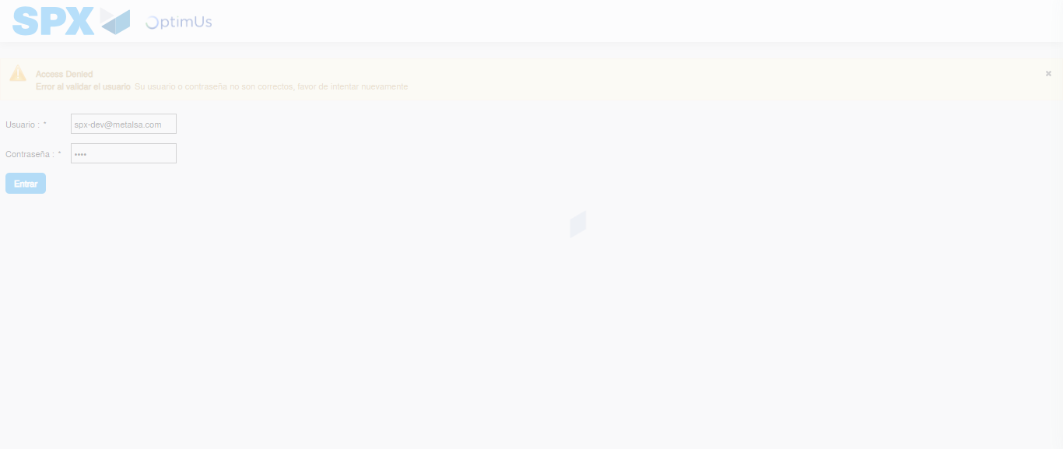Image file-name: QC_Testing-tc001_SPX_Dev5_Crear_Solicitud_Articulo_Almacen-1787932844001

Step 2 - Select to UEN and Access to Request for a New Inventory Item : UEN Correctly selected and Correct access
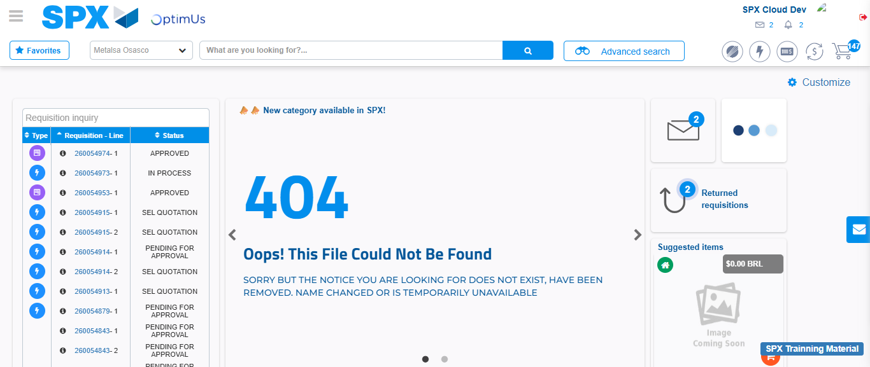Image file-name: QC_Testing-tc001_SPX_Dev5_Crear_Solicitud_Articulo_Almacen-1787932869823

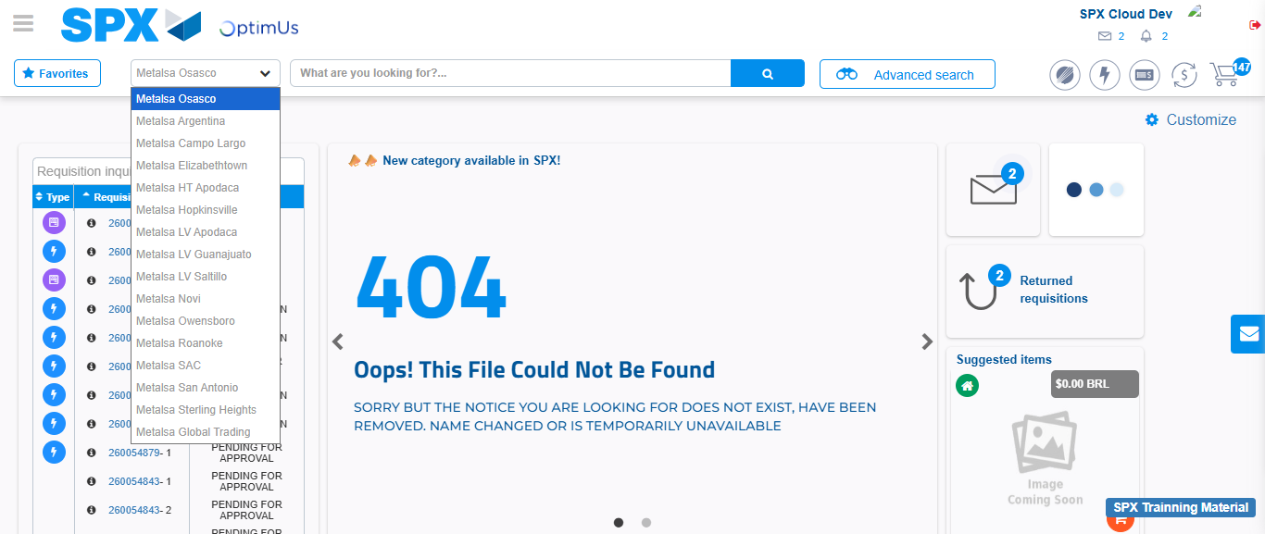Image file-name: QC_Testing-tc001_SPX_Dev5_Crear_Solicitud_Articulo_Almacen-1787932870326

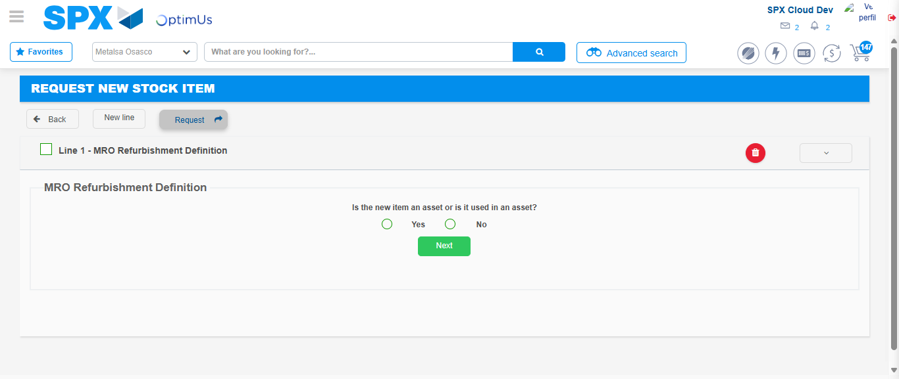Image file-name: QC_Testing-tc001_SPX_Dev5_Crear_Solicitud_Articulo_Almacen-1787932893538

Step 3 - Select options first section : Options seleted correctly
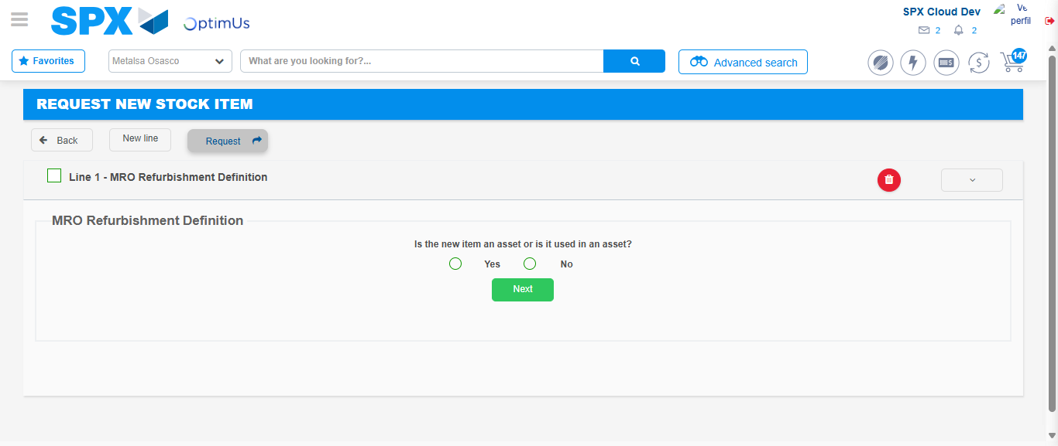Image file-name: QC_Testing-tc001_SPX_Dev5_Crear_Solicitud_Articulo_Almacen-1787932893843

Image file-name: QC_Testing-tc001_SPX_Dev5_Crear_Solicitud_Articulo_Almacen-1787932894038

Step 4 - Select options at Screen: Options seleted correctly
Image file-name: QC_Testing-tc001_SPX_Dev5_Crear_Solicitud_Articulo_Almacen-1787932893843

Image file-name: QC_Testing-tc001_SPX_Dev5_Crear_Solicitud_Articulo_Almacen-1787932894038

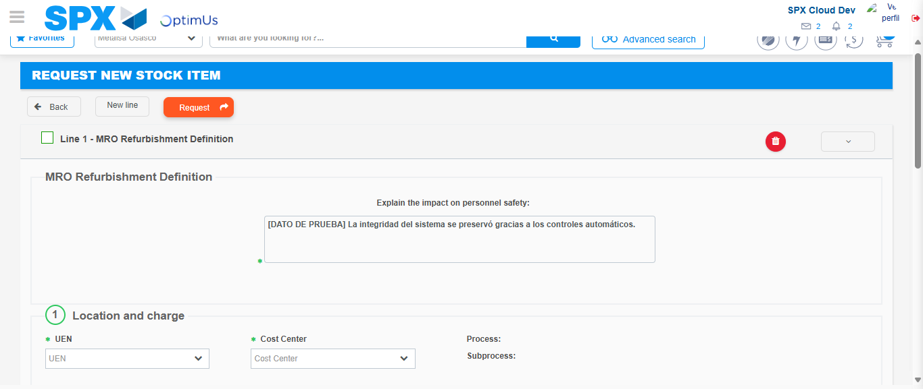Image file-name: QC_Testing-tc001_SPX_Dev5_Crear_Solicitud_Articulo_Almacen-1787932900263

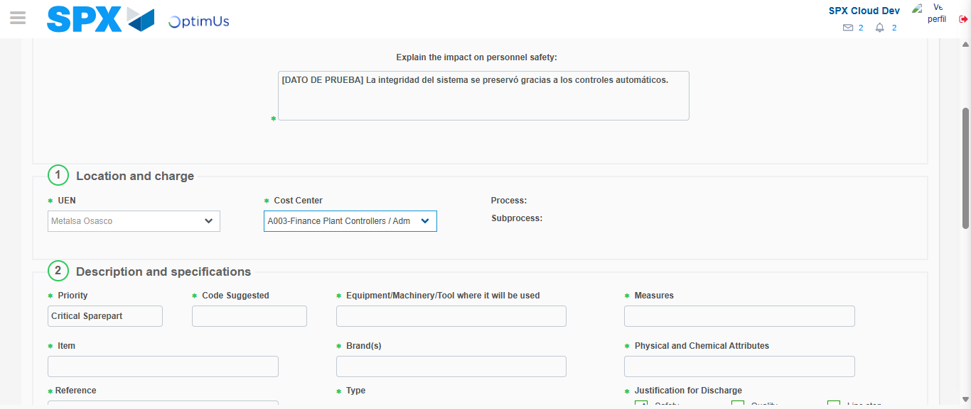Image file-name: QC_Testing-tc001_SPX_Dev5_Crear_Solicitud_Articulo_Almacen-1787932903037

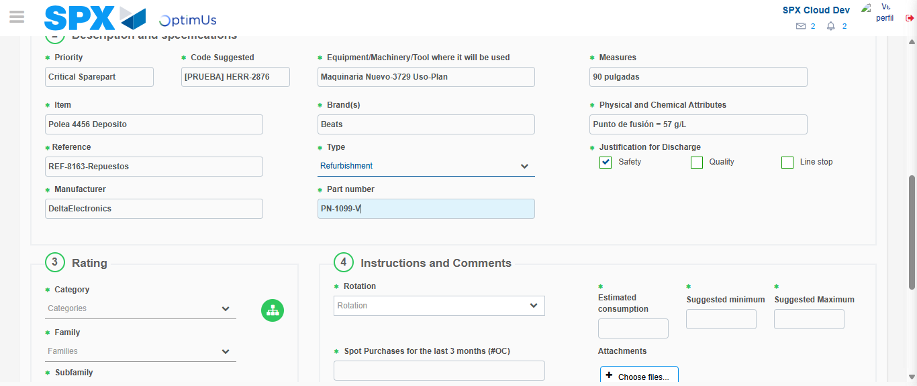Image file-name: QC_Testing-tc001_SPX_Dev5_Crear_Solicitud_Articulo_Almacen-1787932905118

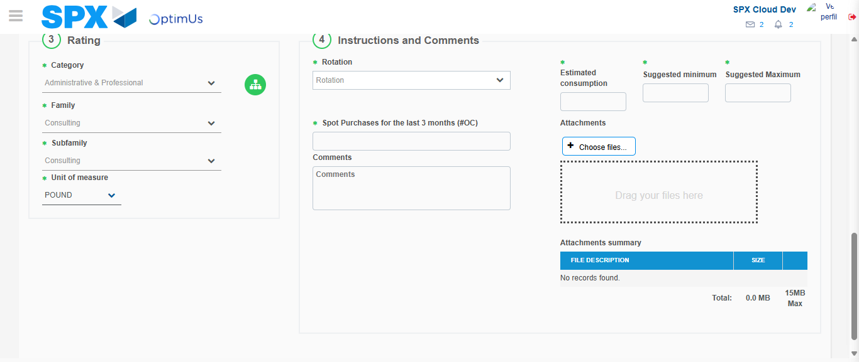Image file-name: QC_Testing-tc001_SPX_Dev5_Crear_Solicitud_Articulo_Almacen-1787932910103

Step 5 - Request New Item : Request Accepted
Image file-name: QC_Testing-tc001_SPX_Dev5_Crear_Solicitud_Articulo_Almacen-1787932869823

Image file-name: QC_Testing-tc001_SPX_Dev5_Crear_Solicitud_Articulo_Almacen-1787932870326

Image file-name: QC_Testing-tc001_SPX_Dev5_Crear_Solicitud_Articulo_Almacen-1787932893538

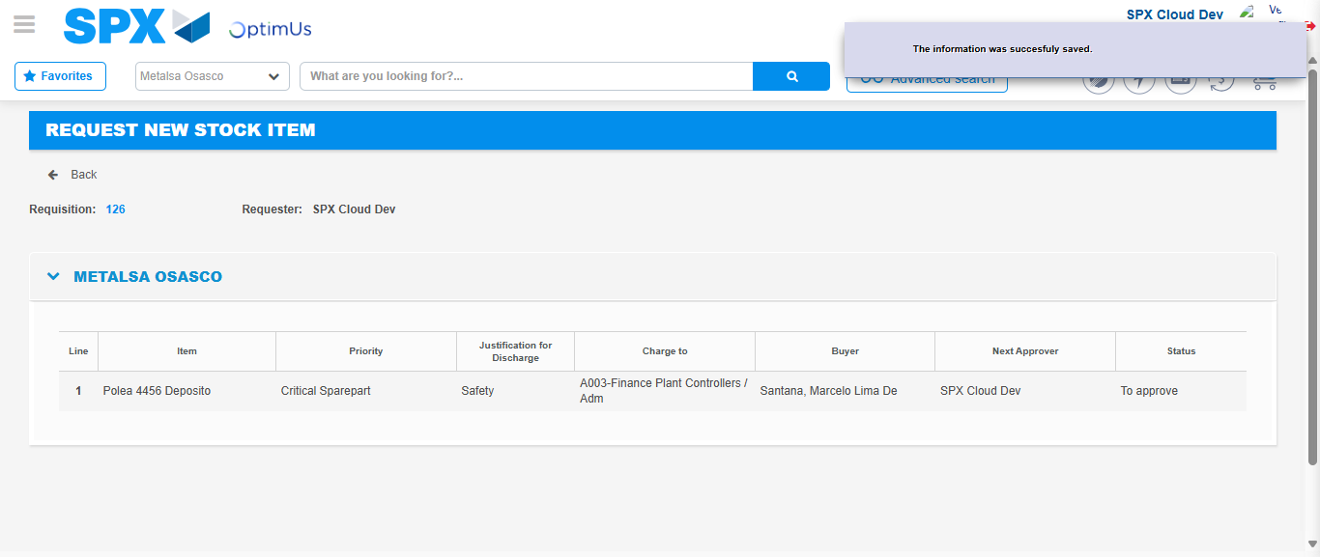Image file-name: QC_Testing-tc001_SPX_Dev5_Crear_Solicitud_Articulo_Almacen-1787932916852

Image file-name: QC_Testing-tc001_SPX_Dev5_Crear_Solicitud_Articulo_Almacen-1787932917057

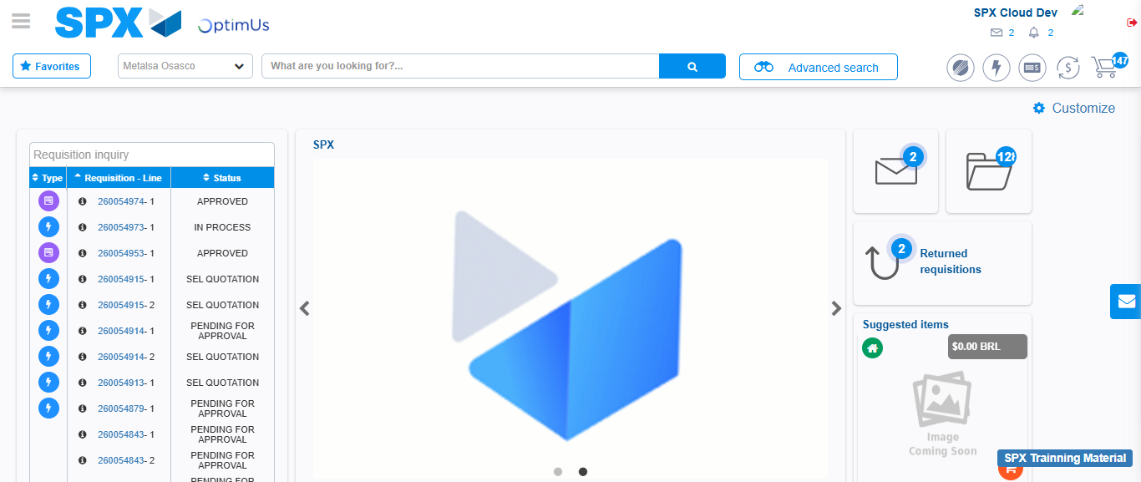Image file-name: QC_Testing-tc001_SPX_Dev5_Crear_Solicitud_Articulo_Almacen-1787932938482

Step 7 - Return to Main Page SPX : Return to Main Page SPX
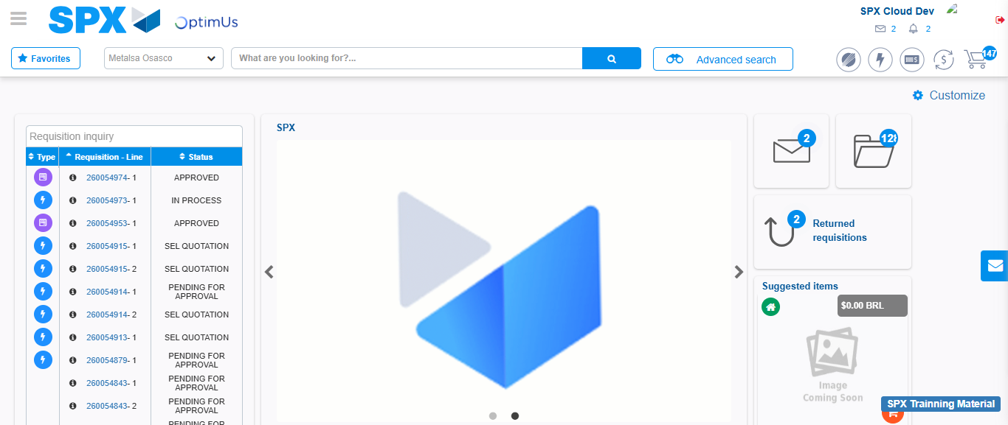Image file-name: QC_Testing-tc001_SPX_Dev5_Crear_Solicitud_Articulo_Almacen-1787932938809

